My favorite university name is Tsinghua university

Tsinghua University is one of the top public universities in Beijing, China (Mainland). It is ranked #20 in QS World University Rankings 2025.

The campus of Tsinghua University is situated in northwest Beijing on the site of the former imperial gardens of the Qing Dynasty.

Tsinghua is a dynamic global university renowned for its high-quality teaching and research, and its spirit of social commitment. With an enduring dedication to excellence and innovation, Tsinghua is committed to inspiring future global leaders.

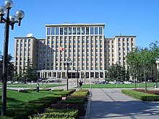

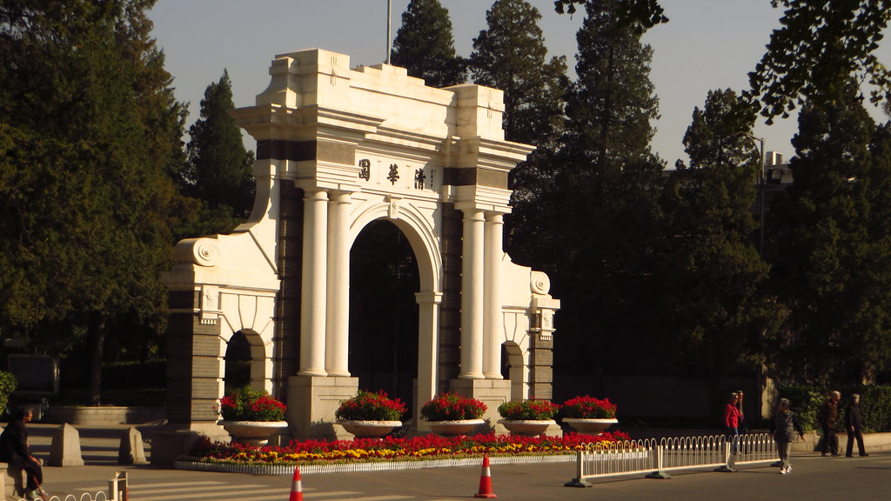

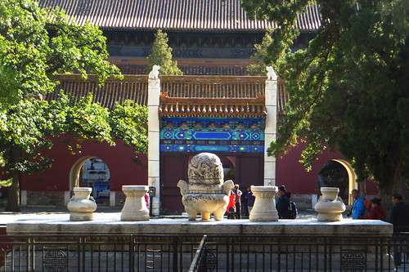

Tsinghua University was established in 1911, originally under the name “Tsing Hua Imperial College”. The school was renamed "Tsing Hua College" in 1912. The university section was founded in 1925. The name “National Tsing Hua University” was adopted in 1928.

* Student life at Tsinghua extends far beyond academic courses. Athletics, performing arts, a vast array of clubs and societies, and diverse social activities not only complement a student's studies at Tsinghua, but also offer wonderful opportunities for friendship and learning.

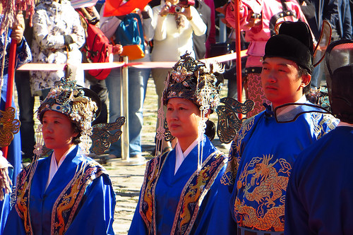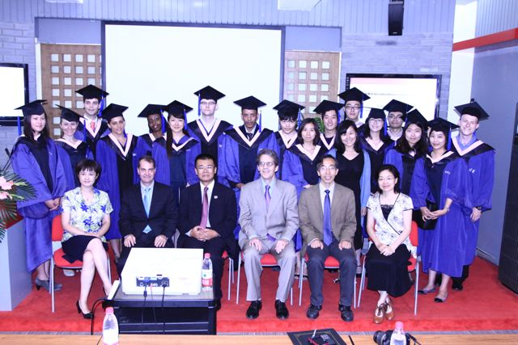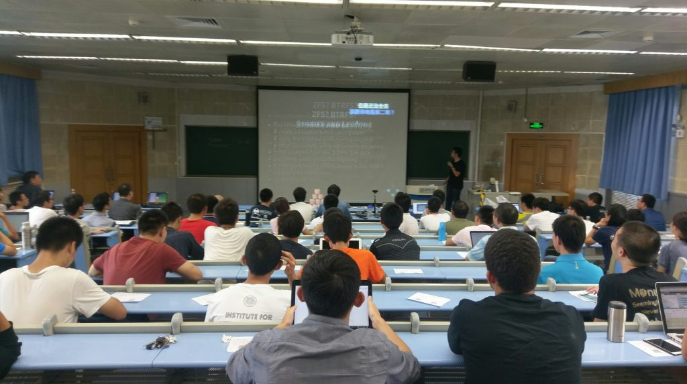

* The International Student Apartment provides three types of dormitories: double room (two beds in one room, shared bathroom on each floor), triple room (three beds in one room, shared bathroom on each floor), AB room (independent bedroom and two persons shared bathroom).

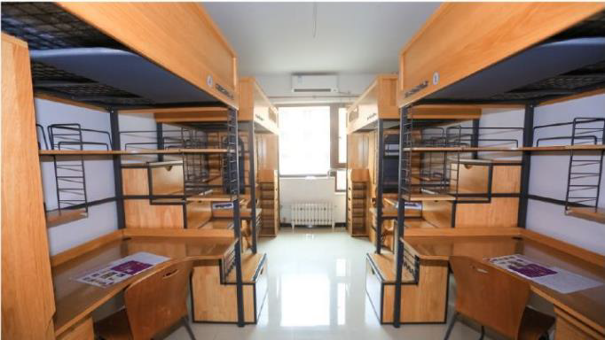

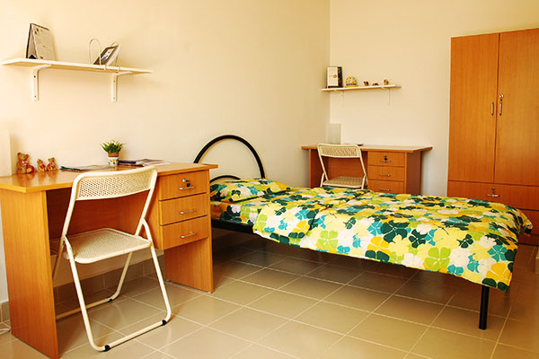

* Tsinghua has a large number of canteens that serve a wide variety of dishes and conform to a high level of food safety standards. Meals are provided for breakfast, lunch and dinner. The 1st floor of Yushu Yuan and the 3rd floors of Guanchou Yuan, Taoli Yuan and Xichun Yuan all offer restaurant-style table service.

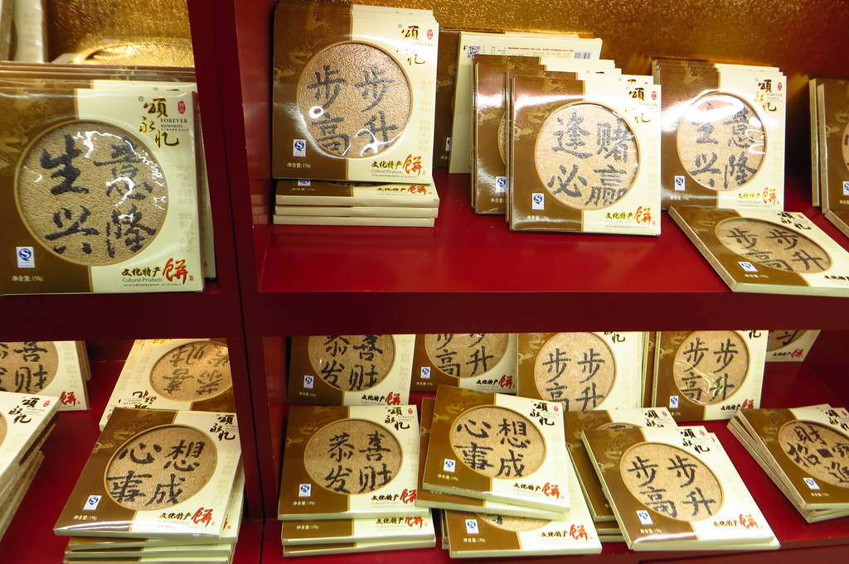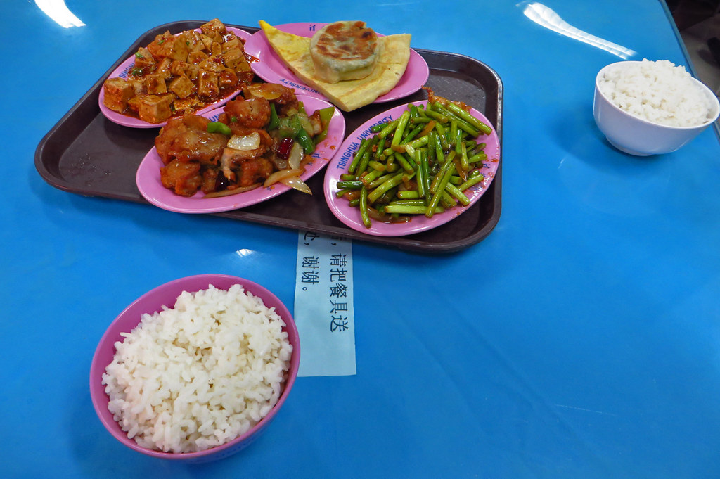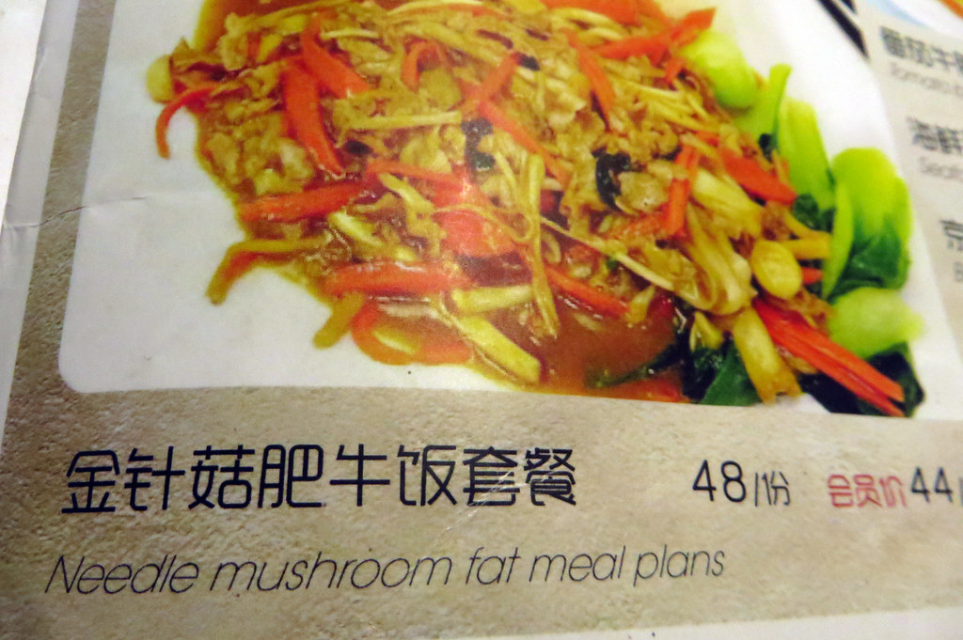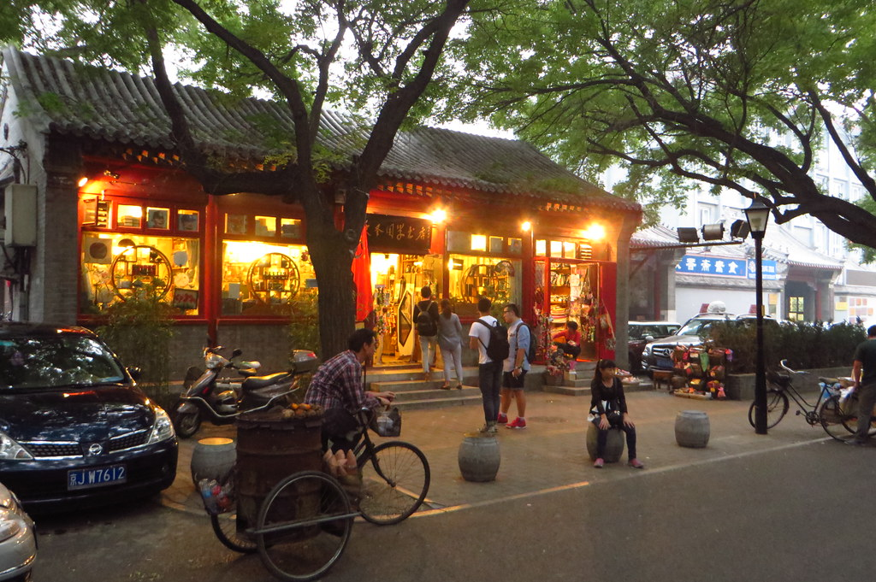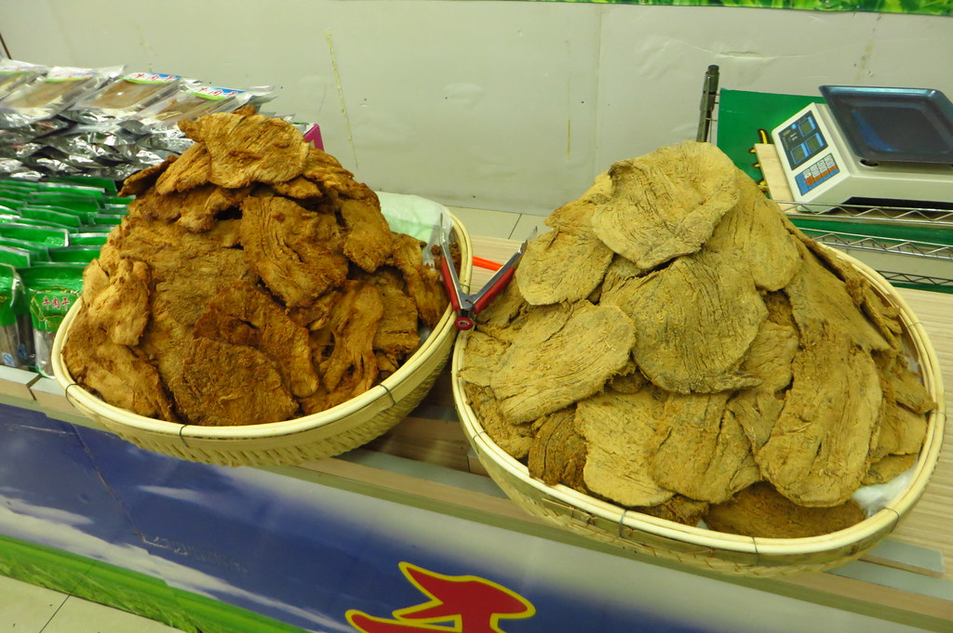

THE END